The red arrow shows the spark electrode for the Dometic series fridge. The notched area is where the gas exits the burner tube. Too close or too far it will not light. The thermocouple must be positioned correctly as well. Problems with the thermocouple may exist if the unit lights, but does not stay lit (think pilot light). If no spark is observed at the spark electrode, check the back of the panel for a disconnected wire. I can access mine through the radio hole. I’ve bent the pins a little for this single wire plug as it tends to fall out on rough roads. If it doesn’t light within 10 presses of the piezo lighter, I pull out the radio and check the plug.

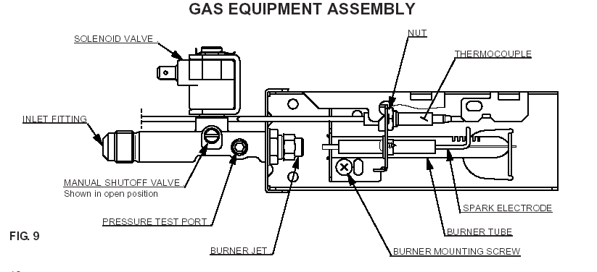

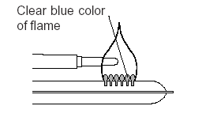

Thermocouple in flame.

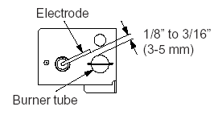

Spark electrode adjustment. The solenoid is above the burner tube.

